# Workshop: Petstagram

We will be creating a complete Django project called **"Petstagram"** throughout this module. The project will cover the following **functionalities**: user **registration**, **login**, and **logout**; each user can **add pets** to their profile and **upload pet photos**; a user can **view all photos** of pets, open **details**, where can **like** and **comment** on a photo. Each user can **edit** and **delete** **their** **photos** and **pet** information.

The full project description can be found in the [**Workshop Description Document**](http://svn.softuni.org/admin/svn/python-web/Sept-2022/Python-Web-Basics/06-Workshop-Part-1/06-Workshop-Description.docx).

## Workshop - Part 1.1

### Setup

Let us start by **creating the project**:

To check if everything works correctly, we can start the development server. One way to do it is to use the PyCharm Toolbar:

Another way to do this is to write the command **python manage.py runserver** in the Terminal and click on the provided link:

### Creating the Apps

Now, let us create the **apps** we will work with. They are called **'photos'**, **'pets'**, **'accounts'**, and **'common'** and they will contain all **parts** of our **project**:

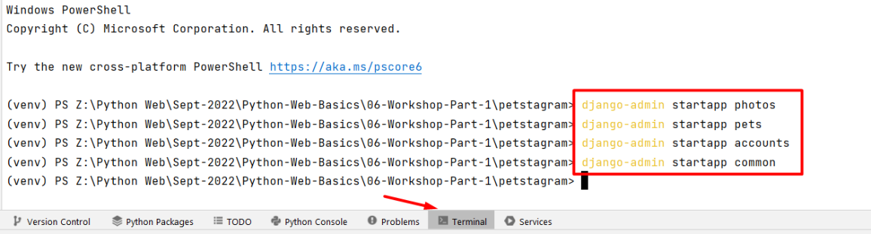

For clarification, **move the created apps inside** the project:

### Configurations

We need to **add the apps** we just created in the **INSTALLED_APPS** setting:

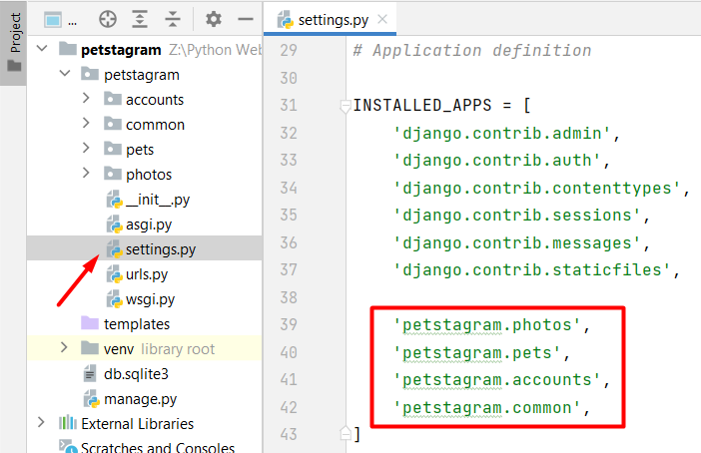

## Workshop - Part 1.2

### Adding the Templates

The next step is to **create** the **templates folder inside each app directory and add the given templates to it**. The templates associated with the account should be added to the **accounts** app:

Respectively, the templates associated with the photos should be placed into the **photos** app:

The templates associated with the pets should be placed into the **pets** app:

We can position the home-page template in the **common** app:

The only template left is the **404.html**. By default, it should be put inside the project **templates** directory on the **manage.py** level:

### Adding the Static Files

Add a directory called **static** on the **manage.py** level:

Add the provided folders ("css" and "images") to the directory. Next, Django should find the static files when loading web pages, so write the setting in the **settings.py** file: Graphical user interface, text, application, email

### Adding the URLs (paths)

We want to load each template in the browser using a concrete path - each app should load its templates.

To do that, we should add **urls.py** files in each app:

Then, we can start including them in the main project **urls.py** file. We should import the **include()** function from the Django **urls** module, then we can use the **path()** function to **construct a path**, which will **lead to each app** **urlpatterns**:

Next, in **each app create an** **urls.py** file. Then, create paths connected to each view we will configure. Let us start by adding the following paths in the **accounts** app:

Registration Page: <http://127.0.0.1:8000/accounts/register/>

Login Page**:** <http://127.0.0.1:8000/accounts/login/>

Profile Details Page: [http://127.0.0.1:8000/accounts/profile/<int:pk>/](http://127.0.0.1:8000/accounts/profile/%3cint:pk%3e/)

Profile Edit Page: [http://127.0.0.1:8000/accounts/profile/<int:pk>/edit/](http://127.0.0.1:8000/accounts/profile/%3cslug:username%3e/edit/)

Profile Delete Page: [http://127.0.0.1:8000/accounts/profile/<int:pk>/delete/](http://127.0.0.1:8000/accounts/profile/%3cslug:username%3e/delete/)

In order to do that, we should create a **urlspatterns** list in the **accounts/urls.py** file: 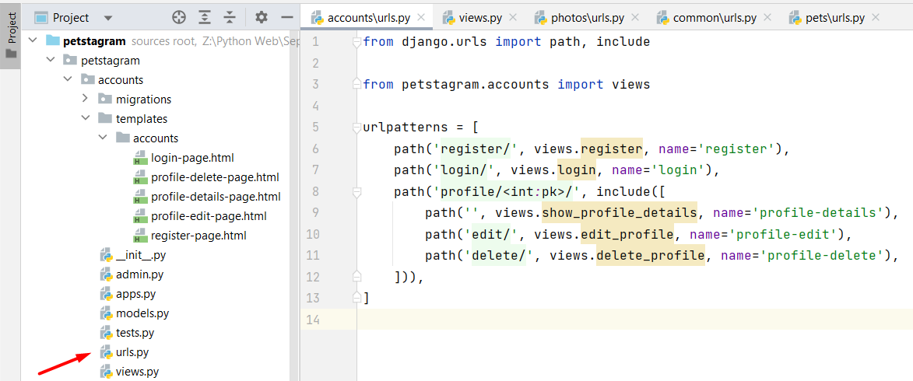

The same configuration should be added to the other apps for the following URLs:

Home Page: [http://127.0.0.1:8000/](http://127.0.0.1:8000/photos/add/)

Photo Add Page: <http://127.0.0.1:8000/photos/add/>

Photo Details Page: [http://127.0.0.1:8000/photos/<int:pk>/](http://127.0.0.1:8000/photos/%3cint:pk%3e/)

Photo Edit Page: [http://127.0.0.1:8000/photos/<int:pk>/edit/](http://127.0.0.1:8000/photos/%3cint:pk%3e/edit/)

Pet Add Page: <http://127.0.0.1:8000/pets/add/>

Pet Details Page: [http://127.0.0.1:8000/pets/<str:username>/pet/<slug:pet_name>/](http://127.0.0.1:8000/pets/%3cstr:username%3e/pet/%3cslug:pet_name%3e/)

Pet Edit Page: [http://127.0.0.1:8000/pets/<str:username>/pet/<slug:pet_name>/edit/](http://127.0.0.1:8000/pets/%3cstr:username%3e/pet/%3cslug:pet_name%3e/edit/)

Pet Delete Page: [http://127.0.0.1:8000/pets/<str:username>/pet/<slug:pet_name>/delete/](http://127.0.0.1:8000/pets/%3cstr:username%3e/pet/%3cslug:pet_name%3e/delete/)

### Adding Views

As you see, we have not created the views so far, and they appear to be missing in the **urls.py** file. Now, we will start adding them to the **views.py** file for each app. For example, we will use the names of the views created in the **accounts/urls.py** file to create the views in the **accounts/views.py** file: Graphical user interface, application

Each view should receive a request and return a response. The response we want to return is a rendered HTML page we already added to our **templates/accounts** directory. Let us write a render function for each view to return: Graphical user interface, text, application, email

The first parameter the **render()** function accepts is the given request. Next, we could pass the template we want to be shown when loading the specific path. In this case, when we load <http://127.0.0.1:8000/accounts/register/> we should see the register-page template:Graphical user interface, application

In the same way we can **create all views** in the project.

## Workshop - Part 1.3

### Creating Template Inheritance

If we look closely at each template, we can see that there are many common parts. The head, the header with the navigation bar, and the footer are the same for all templates. We can export them in a separate **.htm**l file in the project's **template** directory.

Let us create a **base.html** template in the **templates** directory on the **manage.py** level. We will position it there because the code is common for all apps:

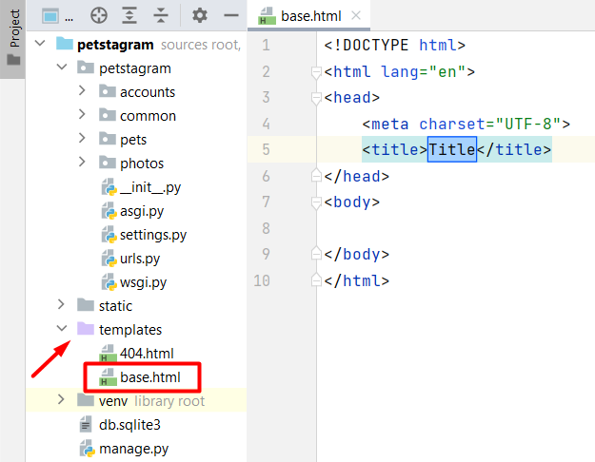

Now, we can add **all common parts** that will structure the **base** template:

<!DOCTYPE html>  
<html lang="en">  
*<!-- Starts Head Section -->*<head>  
 <link rel="stylesheet"  
 href="/static/css/styles.css">  
 <link rel="icon" type="image/x-icon" href="/static/images/free-30-instagram-stories-icons23_122570.png">  
 <title>Petstagram</title>  
</head>  
*<!-- End Head Section -->  
<!-- Starts Body Section -->*<body>  
*<!-- Starts Header Section with Navigation Bar -->*<header>  
 <nav class="navbar">  
 <div class="container">  
 <div class="logo">  
 *<!-- Link to Home Page -->* <a href="#"><img width="50px" src="/static/images/free-30-instagram-stories-icons23_122570.png" alt="img1"></a>  
 *<!-- Link to Home Page -->* <a class="home" href="#"><i>Petstagram</i></a>  
 </div>  
 <div class="nav-links">  
 <ul class="nav-group">  
 <li class="nav-item">  
 *<!-- Link to Add Pet Page -->* <a href="#"><i>Add Pet</i></a>  
 </li>  
 <li class="nav-item">  
 *<!-- Link to Add Photo Page -->* <a href="#"><i>Add Photo</i></a>  
 </li>

<li class="nav-item">  
 *<!-- Link to Login Page -->* <a href="#"><i>Login</i></a>  
 </li>

<li class="nav-item">  
 *<!-- Link to Register Page -->* <a href="#"><i>Register</i></a>  
 </li>  
 <li class="nav-item">  
 *<!-- Link to Profile Page -->* <a href="#">  
 <i>Profile</i>  
 </a>  
 </li>  
 </ul>  
 </div>  
 </div>  
 </nav>  
</header>  
*<!-- End Header Section with Navigation Bar -->  
<!-- Starts Main Section -->*<main>  
</main>  
*<!-- End Main Section -->  
...*

*...  
<!-- Start Footer Section -->*<div class="footer">  
 <span class="footer-section">© 2022 SOFTUNI WORKSHOP FOR PYTHON WEB MODULE</span>  
</div>  
*<!-- End Footer Section -->*</body>  
</html>

Next, we should connect the **base** template with all the other templates. In the **base** template **mark the place where the code should be extended** - it is only the main part:

<!DOCTYPE html>  
<html lang="en">  
*...  
 <!-- Starts Main Section -->* <main>

**{% block content %}  
 {% endblock %}**

</main>

*<!-- End Main Section -->*  
*...*  
</html>

We should **delete the common part of each template** and **add the appropriate tags**. For example, the **register-page** template should look like this:

**{% extends 'base.html' %}**  
  
**{% block content %}**

*<!-- Start Register Section-->*  
 <div class="login-register-div">  
 <div class="login-register-box">  
 <h1>Petstagram</h1>

*<!-- Start Register Form-->*  
 <form action="">  
 <input type="text" placeholder="Username"><br>  
 <input type="email" placeholder="Email"><br>  
 <input type="password" placeholder="Password"><br>  
 <input type="password" placeholder="Repeat Password"><br>

*<!-- Register Button-->*  
 <button type="submit">Register</button>  
 </form>

*<!-- End Register Form -->*

</div>  
 <div class="second-option"><p>Have an account?

*<!-- Link to Login Page-->*

<a href="#">Log in</a></p>

</div>  
 </div>

*<!-- End Register Section-->*

**{% endblock %}**

### Separating Common Parts

We can see that there are **common parts for couple of pages**. Let us start by checking the templates **home-page.html** and **pet-details-page.html** - both templates have pet photos (posts) part: A picture containing text, salamander, different

We can move it to separate template and then include the template in **home-page.html** and **pet-details-page.html**. So, let us **create a new template** called **pets-photos.html** in the **common** app: Graphical user interface, text, application, Word

Then, **move all the posts** **with photos** to the **pets-posts.html** and include the template using the **include** template tag in the **home-page.html**:

{% extends 'base.html' %}  
  
*<!-- Main Code -->*{% block content %}  
 <div class="container">  
 <div class="col-9">  
  
 *<!-- Searchbar -->* <form class="searchbar" method="post">  
 <input type="text" placeholder="Search by pet name...">  
 <button>  
 <img src="/static/images/search.png" height="18" alt="img2">  
 </button>  
 </form>  
  
 **{% include 'common/pets-posts.html' %}**  
  
 </div>  
 </div>  
{% endblock %}

Next, delete the pets' photos in the **pet-details-page.html** template and include the **pets-post.html template**:

{% extends 'base.html' %}  
{% block content %}  
 <div class="pet-profile">  
 <div class="profile">  
 <div class="profile-data">  
 <div class="profile_img">  
 <div class="image">  
 <img src="https://encrypted-tbn0.gstatic.com/images?q=tbn:ANd9GcTgoIHq82qLYnvomfz5ZkW5CLQ8VNxCyI-hUw&usqp=CAU"  
 alt="img8">  
 </div>  
 </div>  
 <div class="personal">  
 <div class="edit">  
 <p>Sasho</p>  
 <a href="">  
 <img class="edit-img" src="/static/images/edit-pen-icon-6.jpg" alt="edit button">  
 </a>  
 <a href="">  
 <img class="bin-img" src="/static/images/icon-remove-22.jpg" alt="bin button">  
 </a>  
 </div>  
 <div class="data">  
 <span>4</span>  
 <p>photos</p>  
 </div>  
 </div>  
 </div>  
 </div>  
 <div class="pet-posts">  
 *<!-- Start if pet photos -->* **{% include 'common/pets-posts.html' %}** *<!-- End if pet photos -->  
  
 <!-- Start if not pet photos -->* <img class="no-posts" src="/static/images/no_posts.png" alt="no posts image">  
 *<!-- End if not pet photos -->* </div>  
 </div>  
  
{% endblock %}

One more thing - you see that there are **3 posts with pet pictures**, so we can **delete two of them** and leave just one that we will work with in the next sessions. **Hint**: it is easy to see the blocks of code when we **collapse the code sections**: Graphical user interface, application

## Workshop - Part 1.4

### Adding Static Files in Templates

Django uses special **template tag** to tell the template engine to **use the files from the static folder**. In each template where we will use static files this tag should be added. In the **base** template it will look like this:

**{% load static %}**  
  
<!DOCTYPE html>  
<html lang="en">  
  
*<!-- Head -->*<head>  
 <link rel="stylesheet" href="**{% static 'css/styles.css' %}**">  
 <link rel="icon" type="image/x-icon" href="**{%** **static 'images/free-30-instagram-stories-icons23_122570.png' %}**">  
 <title>Petstagram</title>  
</head>  
  
*<!-- Body -->*<body>  
  
 *<!-- Header -->* <header>  
 <nav class="navbar">  
 <div class="container">  
 <div class="logo">  
 <a href="#"><img width="50px" src="**{%** **static 'images/free-30-instagram-stories-icons23_122570.png' %}**" alt="img1"></a>

*...*

### Adding Hyperlinks in Templates

In the base template is positioned the **navigation bar**. It navigates the users to different parts of our app. To be fully functional, **hyperlinks should be added** to it. Using Django Template Language, it is not a difficult task to be done. We will use the **url template tag** and map it to the view names that we wrote in the **urlpatterns** list:Graphical user interface, text, application

For now, we **CANNOT add the profile hyperlink implementation**. We will handle it in the **next Web course**.

A thing we could do is to "handle" it by **adding a number for the "pk" parameter**. Any number will work, as there is no implementation for user so far (Note: remember to change it in the future):



### 404 Template

The only thing needed to be done here is **adding a hyperlink** which will lead to the **Petstagram** **home** page. We can **use the url tag**: 

The page is only visible when **DEBUG** setting is set to False. Let us use **"*"** syntax to allow all hosts to reach the app:

When you **start the development server** and try to reach **an invalid page** you should see the **404** Template:

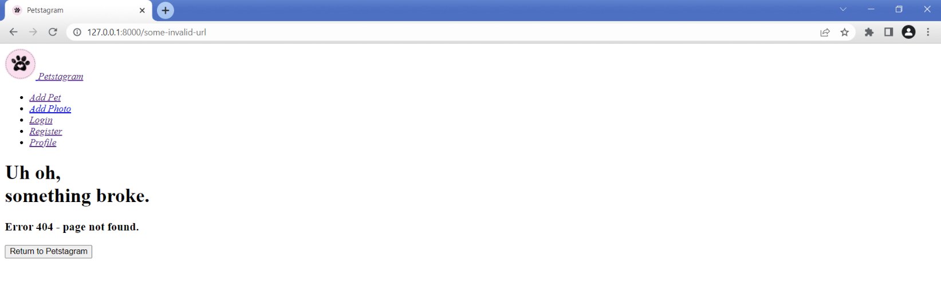

Notice that the HTML is loaded, but the **CSS is NOT loaded**. With debug turned off Django will not handle static files for us. The meaning of **DEBUG** set to **False** is that the app is in production, so the production web server should take care of the style. To test in **DEBUG** **False** mode locally, we can **run the development server** **with a specific command**: **"python manage.py runserver --insecure"**:Graphical user interface
